Grove Key Stage 2 SATs 2023
The school was very pleased with the year 6 Sats results in summer 23, but we only learned how we compare with other schools in December 23. The Teaching and Leaning Committee of governors have looked at the data and would like to share this with parents. We are compared on two areas. Attainment and also Progress from Year 2 to Year 6.
Attainment
Significantly higher than national average in all areas. Very much higher proportion at Greater Depth (GD) in all areas except writing which is close to average. (SPAG = Spelling and Grammar)

Progress
This is based on a child’s score in a subject. For each subject there is an expected score based on how the average child nationally performed at KS1 and then at Key Stage 2.
The Grove scores are: Reading +6.6 Maths +5.7 Writing +0.7
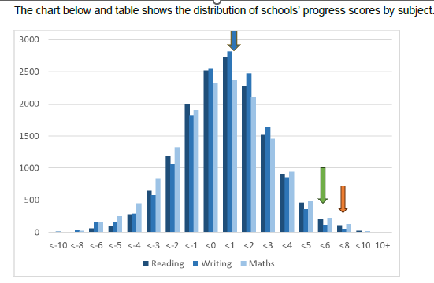
Children at The Grove make some of the best progress in the country in Reading and Maths. Writing is better than average, but we would like this to be even better.
Congratulation to the staff and the pupils for such excellent results.

Mike Waterson, Chair of Teaching and Learning Committee

